**LAB EVALUATION**

**PERFORM USING THE SCREEN SHOT OF YOUR ACCOUNT LOGIN**

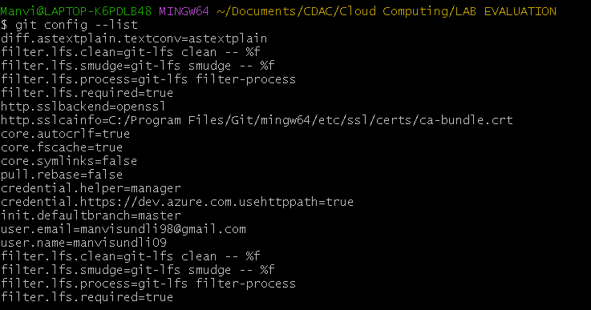

**Create a local git repository**

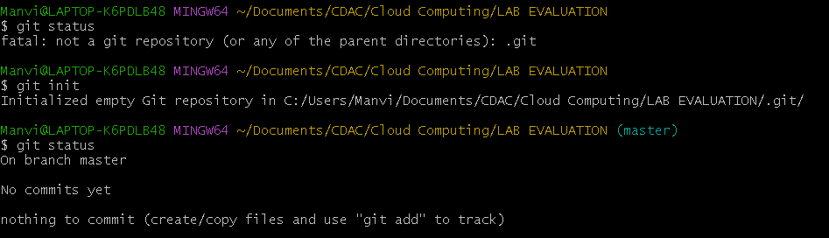

**Commit the initial code**